 | Weekly Team Task Report | #6

Team: GeoLearn |  |  |  |  |  | Date: 10/30/19
Project Title: Improving elementary education with custom online enironmental science lectures

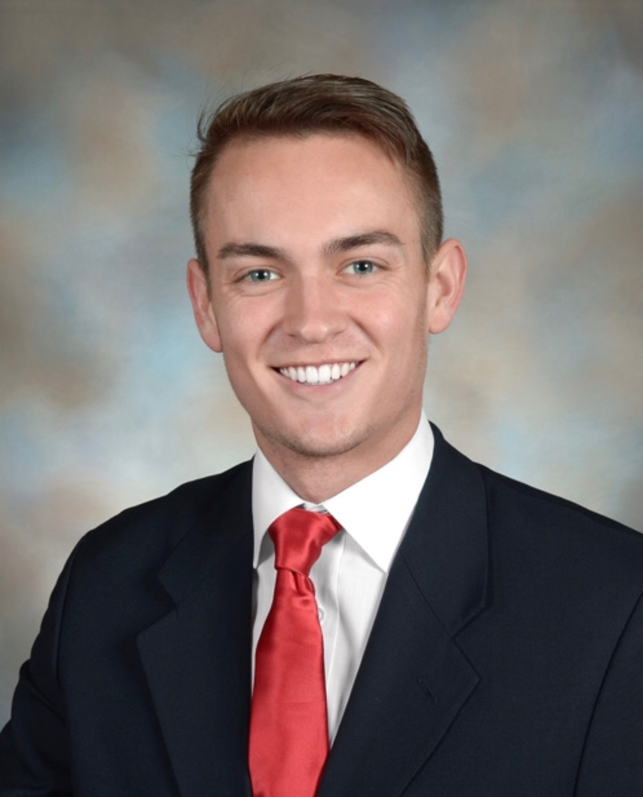 | Samuel Prassse  Present  On-time | 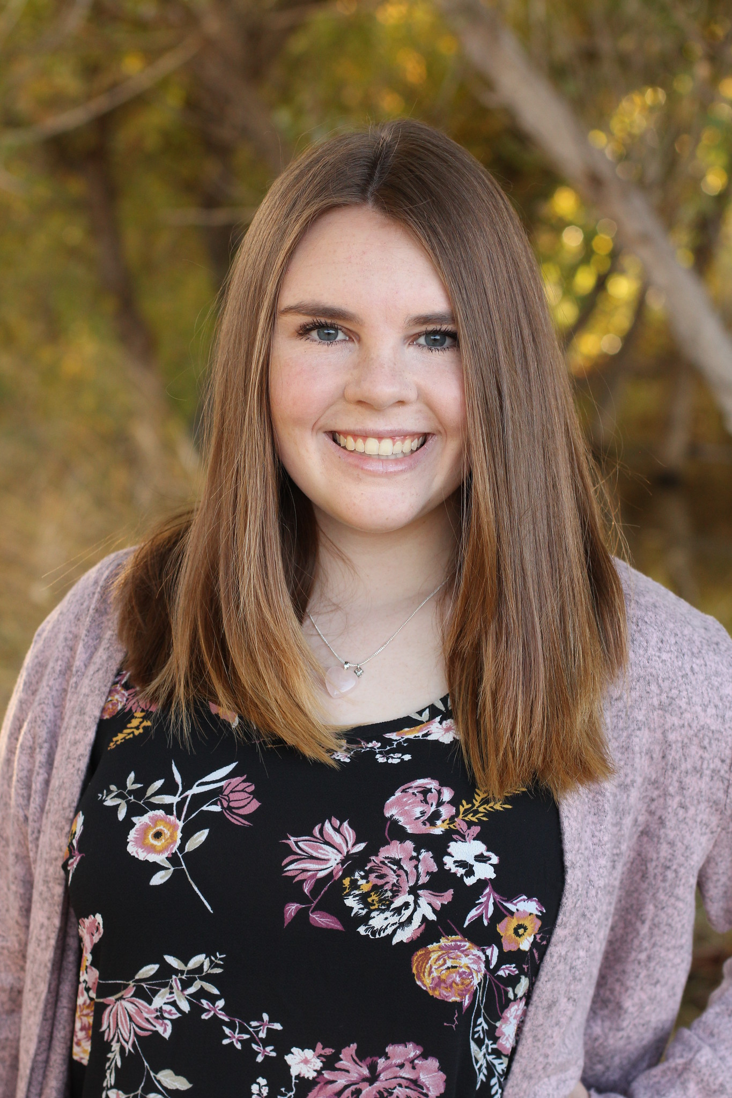 | Kaitlyn Grubb  Present  On-time | 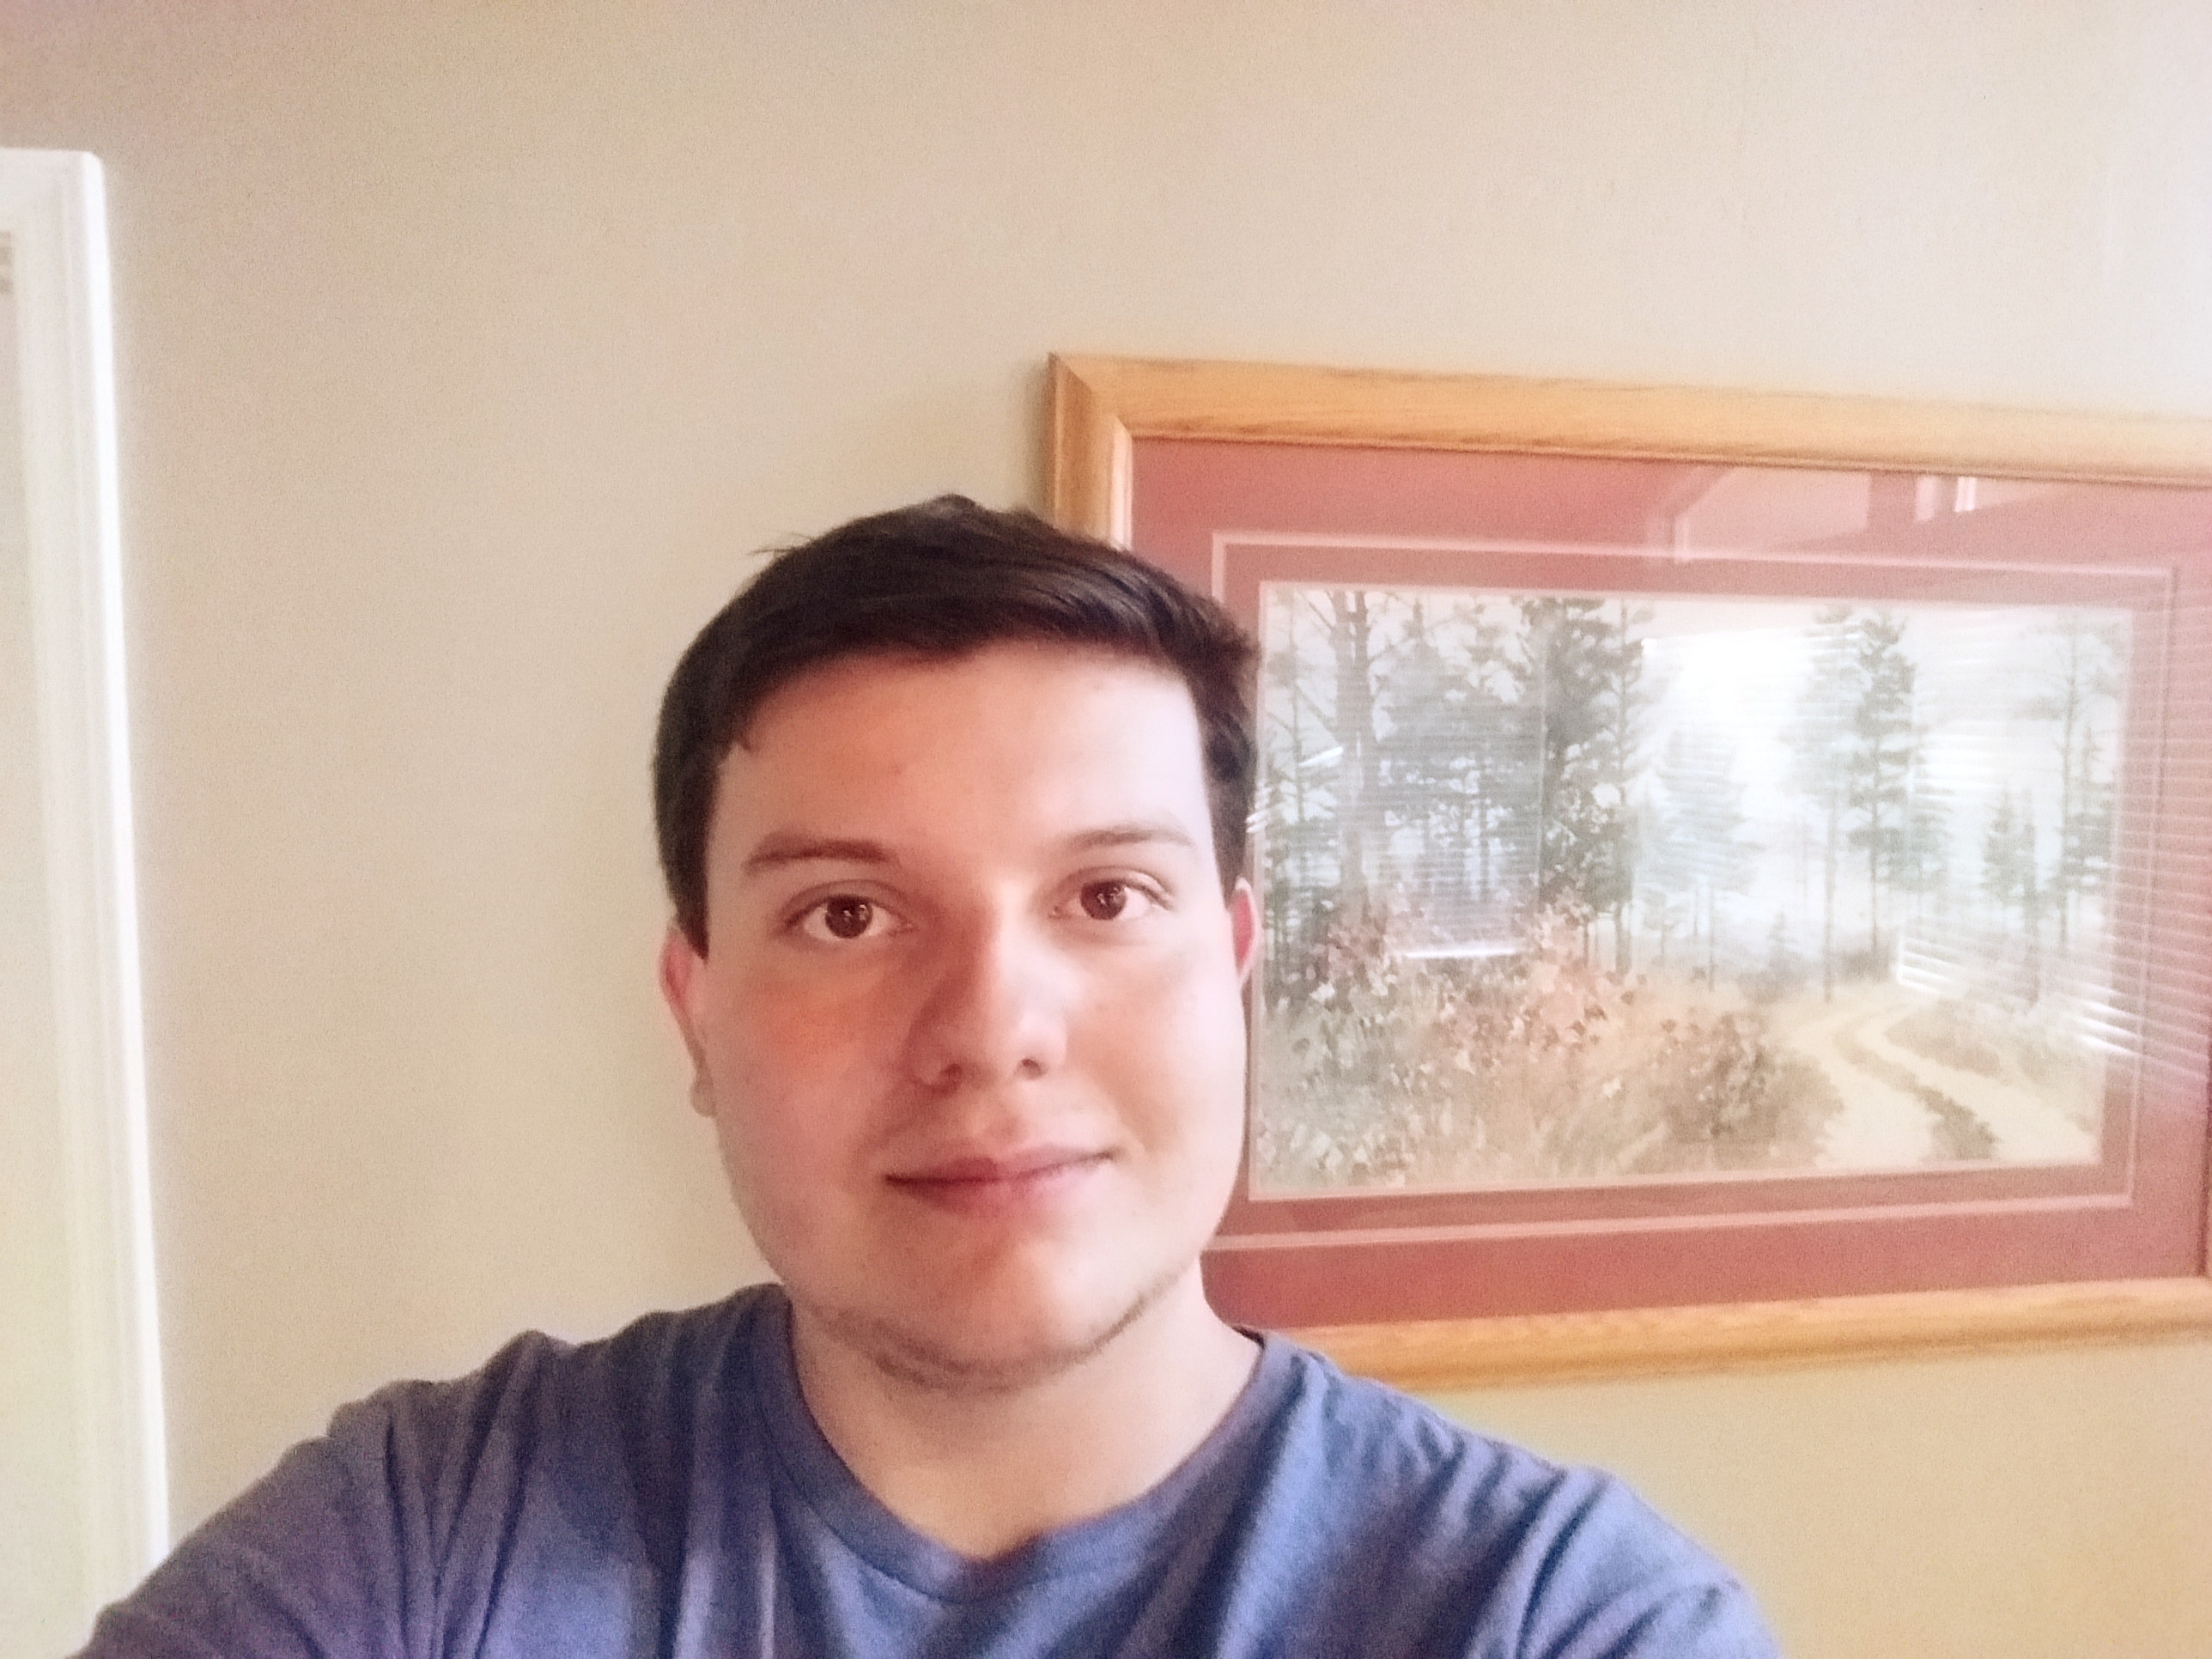 | Tyler Pehringer  Present  On-time |  | 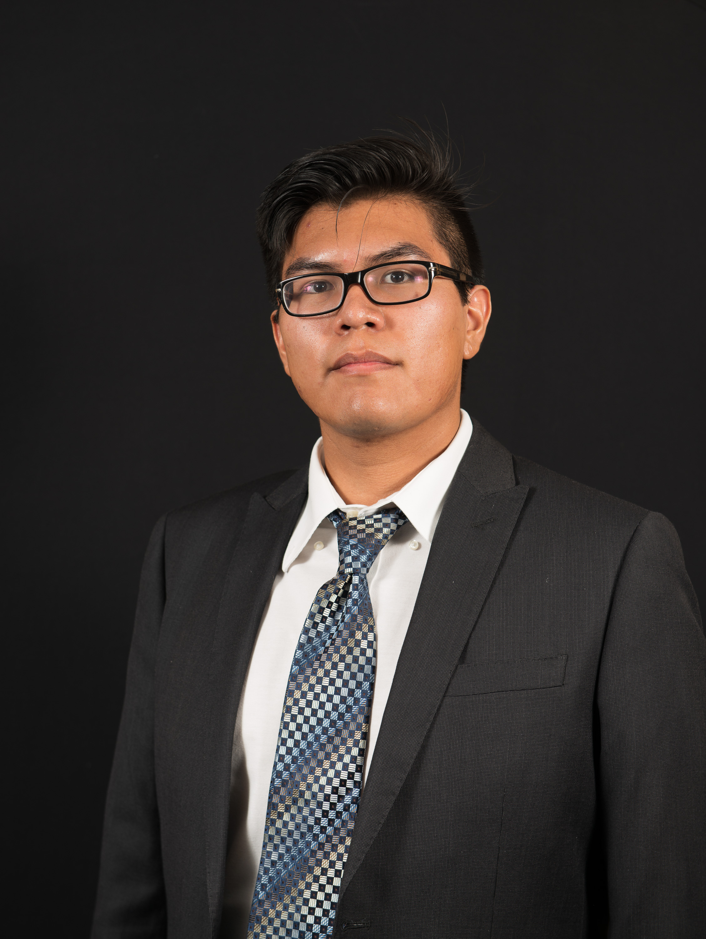 | Joshus Tenakhongva  Present  On-time

Recent Meetings:
- General Team Meeting
- Sponsor Meeting

TASKS COMPLETED since last meeting:

Task Title: Technological Feasibility Analysis Draft | Task Initiation: 10/7 | Orig. Due Date: 10/25 | Status: Completed
Who (%): Joshus (25%), Kaitlyn (25%), Tyler (25%), Samuel (25%)
Description: Create a document describing any technical “challenges” we forsee in our project, and then going through and analyzing each of them: discuss what they are, what needs to be done to tackle it, then outline the alternatives for tackling the challenge, describe what you did to test the alternatives, and end with our well justified decision of which approach yoy plan to pursue.
Expected Outcome: Turn in a bound document of about 5-6 pages and submit it to our CS faculty advisor.

Task Title: Lecture – Requirements in Industry | Task Initiation: 10/2 | Orig. Due Date: 10/25 | Status: Completed
Who (%): Joshus (25%), Kaitlyn (25%), Tyler (25%), Samuel (25%)
Description: This will be a lecture covering requirements in the corporate context. We will cover Capability Maturity Model Integration, requirements engineerings, and general requirements development.
Expected Outcome: To gain an understanding of requirements in industry through an interactive lecture and note taking.

This week’s Tasks: Work plan for coming week
Task Title: Requirements Specification | Task Initiation: 10/30 | Orig. Due Date: 11/22 | Status: In Progress
Who (%): Joshus (25%), Kaitlyn (25%), Tyler (25%), Samuel (25%)
Description: The requirements specification is a description of our project’s requiremtnts, both functional and non-functional, and forms the contractural basis for the expectations to be fulfilled by the development team.
Expected Outcome: Create a document outlining the requirements that the team will stick to when developing our project.

Task Title: Tech. Feasibility Final Draft | Task Initiation: 10/30 | Orig. Due Date: 11/8 | Status: In Progress
Who (%): Joshus (25%), Kaitlyn (25%), Tyler (25%), Samuel (25%)
Description: Create a document describing any technical “challenges” we forsee in our project, and then going through and analyzing each of them: discuss what they are, what needs to be done to tackle it, then outline the alternatives for tackling the challenge, describe what you did to test the alternatives, and end with our well justified decision of which approach yoy plan to pursue.
Expected Outcome: This is the final draft of our technological feasibility document.

Task Title: 3 min Team Update | Task Initiation: 10/30 | Orig. Due Date: 11/8 | Status: In Progress
Who (%): Joshus (25%), Kaitlyn (25%), Tyler (25%), Samuel (25%)
Description: Present our current status to the class during dedicated class time. This will include our tech feasibility document contents (very short overview) and our progress on our requirements document. Also will outline any important items as discussed in the prior weeks meetings with our mentor and sponsor.
Expected Outcome: A short but very informative presentation on our progress from the past month since our last presentation.

Upcoming Tasks: Planning
Task Title: Peer Eval #2 | Who (%): Team (100%) | Rough Due Date: 11/8
Description: Each team member will submit a peer eval to Fabio by Friday November 8th.

Other Problems / Other Issues:
- Have a dialogue about what we should discuss with Dr. Doughty at Friday’s meeting.

